Product Data Sheet 
Equal Tee LM100 400 R3 PC1
Reference MLF1155PC1

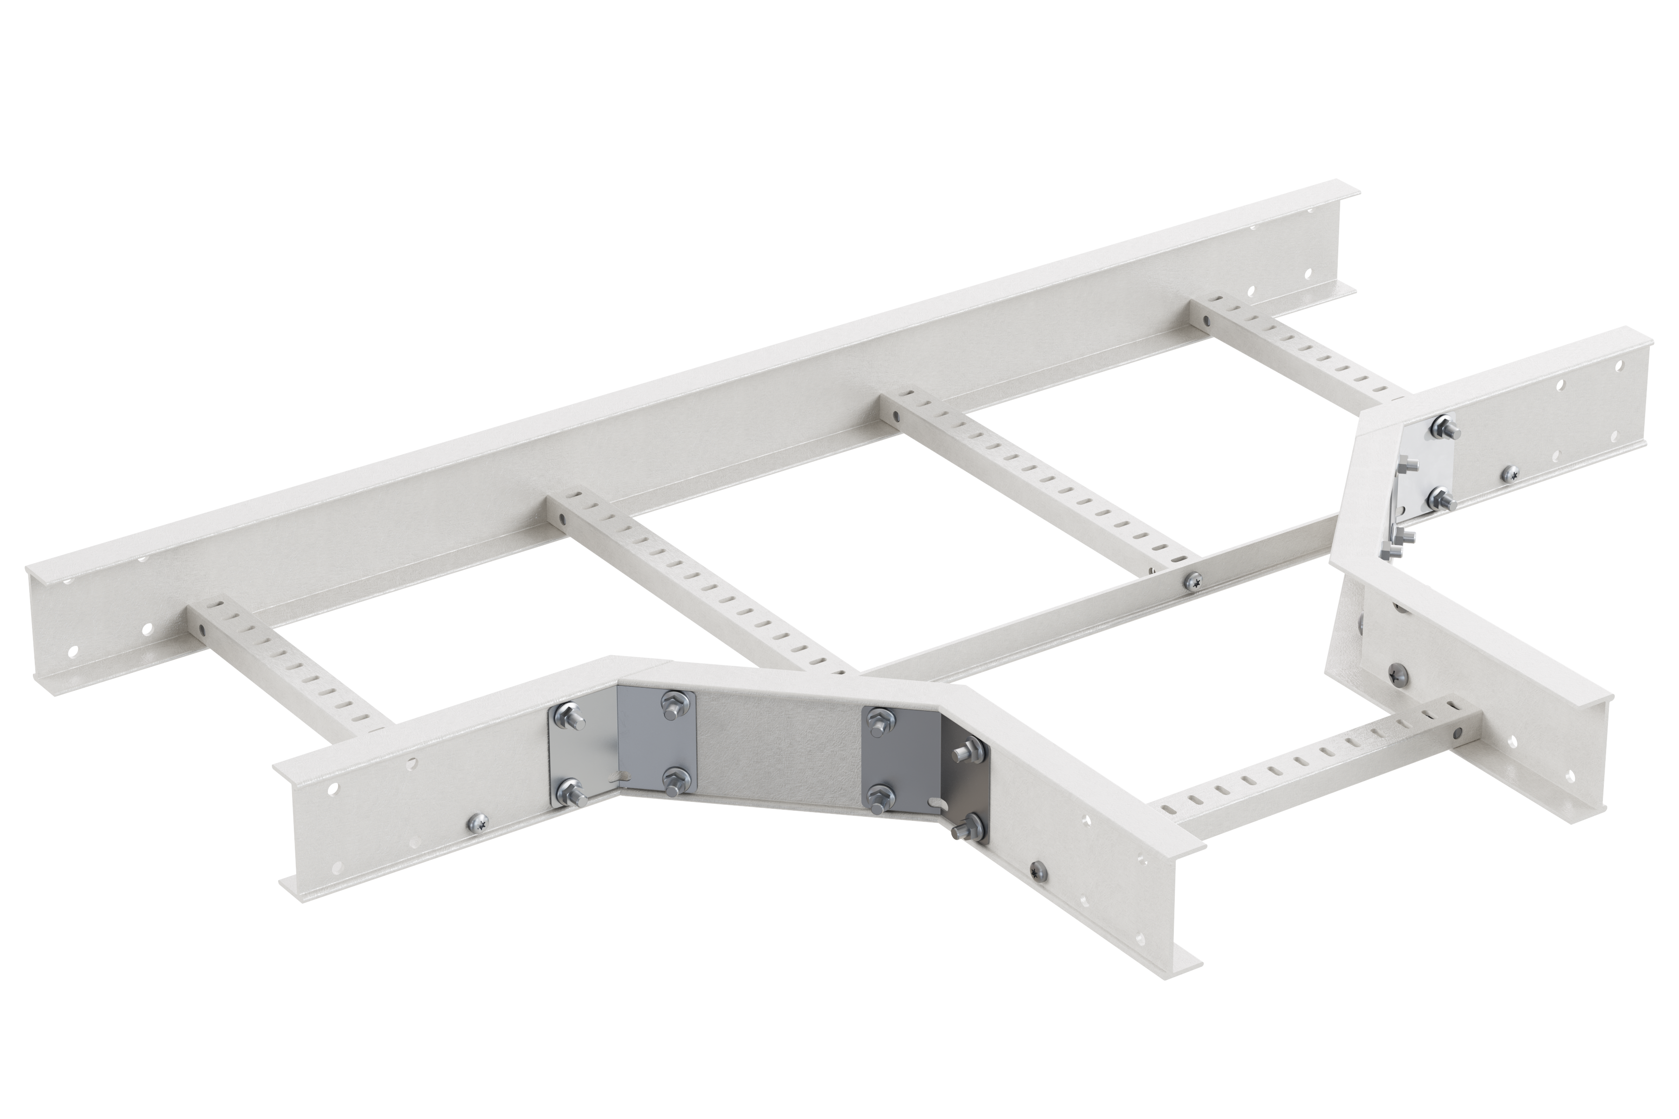

Base

Activity Product family Brand
Range

Cable support systems Cable ladders
Mita Flex

This information is meant as an indication and cannot be used to ensure fitness with any solution. This file is subject to change, for detailed information, please contact our Customer Service.
Activity Cable support systems
Product family Cable ladders
Brand Mita
Range Flex
GTIN 7321678030124

Commercial and Web

Short description Equal Tee LM100 400 R3 PC1
Medium description Equal Tee LM100 400 R3 PC1
Length 1300 mm
Width 858 mm
Height 100 mm
Material GRP
Material type or surface treatment PC1
Environmental corrosion class CX

ETIM (EC001540-Tee for cable ladder)

Type of side joist (EF007666) Profile (open)
Type of rung (EF001060) Perforated profile
Cable ladder height (EF004818) 100 mm
Cable ladder width (EF004817) 400 mm
Cable ladder branch width (EF004816) 400 mm
Symmetrical model (EF006521) Yes

Inner radius (EF004793) 300 mm
This information is meant as an indication and cannot be used to ensure fitness with any solution. This file is subject to change, for detailed information, please contact our Customer Service.
Model (EF000010) Without connector
Wide span model (EF006397) *
Suitable for circuit integrity No (EF007806)
Material (EF002169) Other
Material quality (EF001257) GRP (Glass fibre reinforced plastic)
Surface protection (EF000139) Other
Colour (EF000007) Grey
RAL (EF000116) 7047

Logistic

Customs code 39169010
Net weight 6.8 kg
Country of origin Malaysia

Certification

ETIM class EC001540

Status product

Product status Commercialized

For the latest information check http://wibe-group.com/brand/mita/equal-tee- lm100-400-r3-pc1

